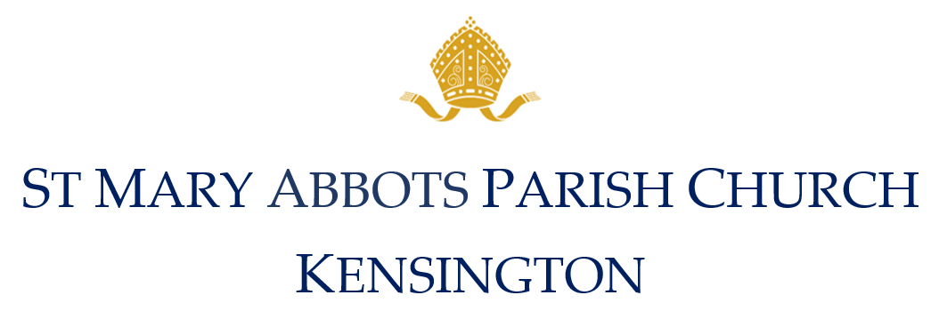

Fees for External Bookings 2024
Concerts, Services and Events

Hire of the Church building for external organisations: £950.00
This block fee includes setup and rehearsal time on the day of the service.

A non refundable deposit will be required to confirm the booking £200.00

Full payment is required one month before the event

Music Fees

All music must be agreed with the Director of Music, Mark Uglow, who will help you with any musical requirements for your event. Email: uglowmark@yahoo.co.uk Tel: 07973 418 826 or

Organist / Organ / Piano
Provision of an organist or use of organ / piano £175.00
If you would prefer to use your own organist please sent their details to or events co-ordinator to forward to our Director of Music for approval,

Church Choir
Our choir of 4-10 singers, all professional and classically trained, can be hired for your event.
Choir per singer (minimum of 4) £110.00
Soloist £175.00

External Choir
Director of Music fee £225.00
For a concert with an external choir or soloists inc. consultation & rehearsal of up to 60 mins
Additional rehearsals: in the daytime £50.00
In the evening (after 6pm) £100.00

If you would like any extra instrumentalists please talk to Mark Uglow directly

Recording / Photography

Recording Musicians
If you decide to film the concert / service all musicians will receive a Copyright Assignment Fee, which is an extra 50% of their fee.

Recording fee £100.00
Even if you have no official videographer, should anyone at the concert make a recording the musicians will be eligible for extra fees. To counter this possibility, an additional £100 will be added to your invoice.

