In Our Prayers This Week

Prayer for Pentecost
O God the Holy Ghost who art light unto thine elect evermore enlighten us. Thou who art fire of love evermore enkindle us. Thou who art Lord and Giver of Life, evermore live in us. Thou who bestowest sevenfold grace, evermore replenish us. As the wind is thy symbol, so forward our goings. As the dove, so launch us heavenwards. As water, so purify our spirits. As a cloud, so abate our temptations. As dew, so revive our languor. As fire, so purge our dross. Christina Rossetti (AD 1830-1894)

The Collect for Pentecost
Holy Spirit, sent by the Father, ignite in us your holy fire; strengthen your children with the gift of faith, revive your Church with the breath of love, and renew the face of the earth, through Jesus Christ our Lord. Amen

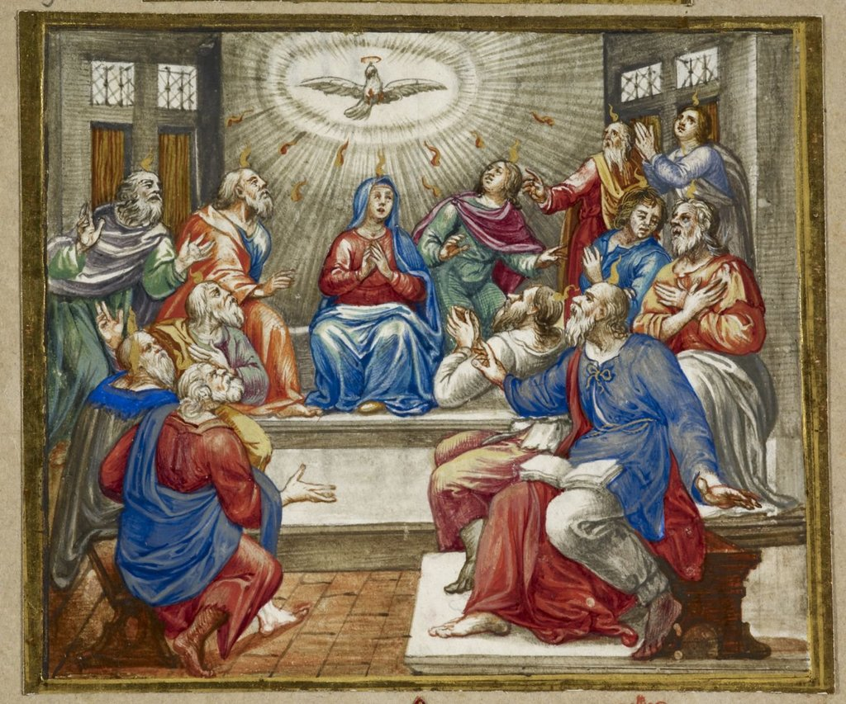
Missals of Innocent X from the British Library

Please remember before God those who have asked for our prayers

Those in acute need  Katie Aston  Francesca de Bono  Rebecca Cable-Nunn  Sarah Deal  Margy Fitter  Tony Gordon  Sarah Hack  Joan Jackson  Margaret Lyon | Mary McKenna  Diana Nicol  Michael North  Holly Raber  Mary Reeve  Maria Reis  June Scully  Sue Spicer  Roger  Rosie  Victoria | Those in long-term need  Vincenzo Blandini  Theo Bulkai  John Cantlie  Rev. Geoffrey Connor  Joan Davies  Leo Koymans  Simon Portal  Annie Redmile  James Worsley

and for all who have died recently
Kevin FitzGerald Amy Johnston Christine Wattlesworth

and for all those whose anniversary of death falls at this time
Edward Haslam, 31st May Darrell Dale, 31st May
Iris Macvie, 2nd June

St MARY ABBOTS CHURCH CONTACTS
Church Website: www.smaw8.org

Vicar Mthr Emma Dinwiddy Smith vicar@smaw8.org 020 7937 6032
Vicar’s PA Leonora Service pa@smaw8.org 020 3479 4731
Associate Vicar Fr Jonathan MacNeaney jm@smaw8.org 07949 468 905
020 7937 2364

Churchwardens Jamie Dunford-Wood jdunfordwood@gmail.com 07732 842 894
David Banks dcjb@btinternet.com 077 3274 3228
Assistant Churchwardens Guy Heald
Ed Warrick

Parish Office: Vacant
Church Vestry: Simon Fitter Head Virger virger@smaw8.org 020 7937 5136
Safeguarding Officer: Andrew Freestone safeguardingofficer@smaw8.org
Children on Sundays Co-ordinator & Children’s Champion:
Martina Sadovska m.sadovska@yahoo.co.uk
ST Mary Abbots Centre: Adam Norton an@smaw8.org 020 7937 8885
Stewardship Secretary: Emma Porteous stewardship@smaw8.org 07866 258 814
Electoral Roll Officer: Ed Warrick er@smaw8.org
Bellringing Secretary: David Holdridge david.holdridge@ntlworld.com 07904 954 959
Friends of ST Mary Abbots: friends@smaw8.org 07585 705 281

ST MARY ABBOTS PARISH CHURCH

NEWSLETTER
31st May 2020

St Mary Abbots church building may be closed, but the St Mary Abbots church community continues strong in faith and fellowship. With technology we continue to pray for one another’s needs and to share each other’s hopes and fears.

A link to all our services will be sent out each week by email and can also be found on our website: www.smaw8.org

DAILY PRAYER
We would like to invite you to join us at a 9am zoom meeting for morning prayer on Monday, Tuesday, Thursday and Friday. If you would be interested in joining us please email Mother Emma vicar@smaw8.org who will send you the invitation.

The Clergy will continue to say the daily office in the quiet of their homes at 8 am on Wednesday and every evening at 5.30 pm. If you would like to be with us in spirit, please do light a candle and use the prayers accessed on this website: https://www.churchofengland.org/prayer-and-worship/join-us-service-daily-prayer

SERVICES
Sunday 31st May
10.30am Holy Eucharist for Pentecost

We have also prepared a Taize prayer and reflection for Ascensiontide which is on our website now.

If you would like to make a donation during our services, or at any time, we have set up an online virtual collection plate HERE:
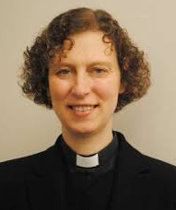
Message from Mother Emma
This Sunday we celebrate one of the great Feasts of the Christian year, as at Pentecost we remember and rejoice in the sending of God's Holy Spirit to us.

Please find on our website the link to our Pentecost Eucharist, coming to you once again from the Vicarage garden and St Mary Abbots - and indeed from the homes of our readers! - as we worship together, giving thanks for our shared communion in the Spirit.

As I write there is no further news about church re-opening from the Church of England or the Diocese of London following the Prime Minister's announcement of some relaxation of the lockdown yesterday, but we are sure that there will be news before too long, and will share it with you as soon as possible. We are grateful that we continue to worship and to support one another as a community, and very much appreciate all your contact and feedback, as well as the very kind donations we have been receiving in our "virtual collection plate".

More positive news from the parish office this week, in the appointment of a new Parish Manager, Petter Kringberg. He has worked both as an administrator and a verger at other churches and Anglican institutions in London and in Oxford, and brings with him broad experience in finance and operations in both churches and charities. Petter will be starting with us on 15th June, and we will ask him to write something (and provide a photo!) in due course.

I hope that you are all still safe and well and pray very much for all of you venturing into a new phase over the next weeks, as well as for everyone who like me has to stay at home for now.

Generous God, you sent your Holy Spirit upon your Messiah at the river Jordan, and upon the disciples in the upper room:
in your mercy fill us with your Spirit, hear our prayer, and make us one in heart and mind to serve you with joy for ever. Amen.
From Common Worship, Liturgy for the Feast of Pentecost, copyright © The Archbishops' Council 2006

With my love and prayers, Mother Emma

Towers of Faith Lecture, Martin Luther

Wednesday 10th June, 7pm
The Rt Rev’d Dr Graham Tomlin, Bishop of Kensington will be online during the Towers of Faith Lectures, a series of free theology seminars that that place every Wednesday night. His subject is Martin Luther who is well known for his advocacy of the authority of Scripture within the church. In this lecture, Bishop Graham will explore why this was so important for Luther, how he felt Scripture should be interpreted, and something of the legacy of Luther’s views on the Bible in subsequent church history and theology. For more details please log onto www.towersoffaith.com

OTHER NEWS

Light a Prayer Candle
On visiting the church we often chose to light a candle when praying for a loved one. The Church of England has provided a virtual prayer candle as a way for people to direct their thoughts towards friends and loved ones during these troublesome times, especially in remembrance of a loved one. They provide a short prayer guide to channel your thoughts and then, by clicking several times on the image, your candle is lit on screen. If you would like to light a prayer candle please follow this link here: https://www.churchofengland.org/life-events/funerals/light-candle-remember-someone

Wild Worship Field Guide
The Sanctuary group, which focus on vibrant and creative ways of praying, have put together a field guide to worshipping outside; a fun, interactive and year long way to be used while on your daily walk. Most of Jesus’ teaching was conducted outside - on hillsides, next to lakes, in boats and is filled with metaphors and stories about the landscape surrounding the people he was speaking too. In our modern lives we sometimes end up losing the richness of the connection between creation and worship and this guide encourages us to take in our surroundings and notice nature. http://thesanctuarycentre.org/resources/creative_prayer_idea_wild_worship_field_guide.pdf
‘Thy Kingdom Come’ - 24 hour Prayer Vigil
The Diocese of London have written to say thank you to everyone who has taken part in the 24 hour vigil that has been held during the 10 days leading up to Pentecost. Christians across the world have been praying together and as people contemplate life’s big questions over this pandemic, process their heartache and search for hope, we pray that they may encounter the love of Christ. There is still time to take part as the vigil ends at midday on Sunday 31st May. For more information please click HERE

Five Fingered Prayer
The Diocese of London have put together a handy prayer tool that will help you in those moments when it can be hard to think of things to pray for. The 5 finger prayer will help give you some direction and, as you have your hands with you all the time, you could do this with your family over dinner, before bed or at any point that takes your fancy. For this you simply need your hand. For each finger there is a different category of person that you can pray for together. You could have you children draw around their hand and then write on each finger who they want to pray for.
Thumb: Those closest to your heart – family and friends
Pointer finger: Those giving direction – teachers, doctors…etc
Index finger: Those in leader – Government, business, church
Ring finger: Those who are weak – sick, poor
Pinky finger: Yourself

Archbishop’s Dial-in Worship Phone Line
Archbishop Justin Welby has set up a phone line for those who wish to worship but cannot use the internet. Callers will hear a special greeting from the Archbishop of Canterbury before being able to chose from a range of options including hymns, prayers, reflections and advice on COVID-19. The number to dial is 0800 804 8044.

Pastoral & Practical Care
We will continue to provide both emotional and spiritual care, both for our own congregation members and locals in the parish who would like a chat. We intend to stay in regular touch, but would also welcome anyone who would like to phone or email us at any point. If you know of anyone in need of support please email Father Jonathan: jm@smaw8.org

Mutual Aid
‘Kensington and Chelsea Mutual Aid’, a group of local volunteers helping the vulnerable, elderly and housebound residents of Kensington & Chelsea with shopping, picking up prescriptions or as a point of contact. As lockdown appears to be easing they have sent out a survey to find out how best to continue the goodwill and engagement with the community into the future. There website: https://www.mutualaidkc.com details all the groups they support and services they offer. Our Sunday school convenor Marina Lussich is the administrator for zone 3 Kensington & Chelsea Mutual Aid - covering Holland, Campden and Pembridge wards.

Food Bank
Now more than ever the foodbank is in need of donations as more people rely on them for provisions. The church is not able to act as a collection point at the moment, however a number of supermarkets are collecting at their exits so please make use of this system. Alternatively you can give financially by sending cheques made payable to ‘Dalgarno Neighbourhood Trust’ and marked ‘foodbank’ on the reverse to: The Dalgarno Trust, 1 Webb Close Dalgarno Way, London, W10 5QB. If you wish to do a direct bank transfer please ask Fr Jonathan (jm@smaw8.org) for the bank details.

Help and Advice from RBKC Council
Kensington and Chelsea Council are offering help and advice on housing support, job retention and self employment claims, support for those feeling anxious of depressed, or help for anyone experiencing domestic abuse or cared for elderly or vulnerable residents as well as a new anti-social line to report those taking advantage of the vulnerable as well as on line activities and for children's during lockdown. Their website is https://www.rbkc.gov.uk/coronavirus-covid-19

